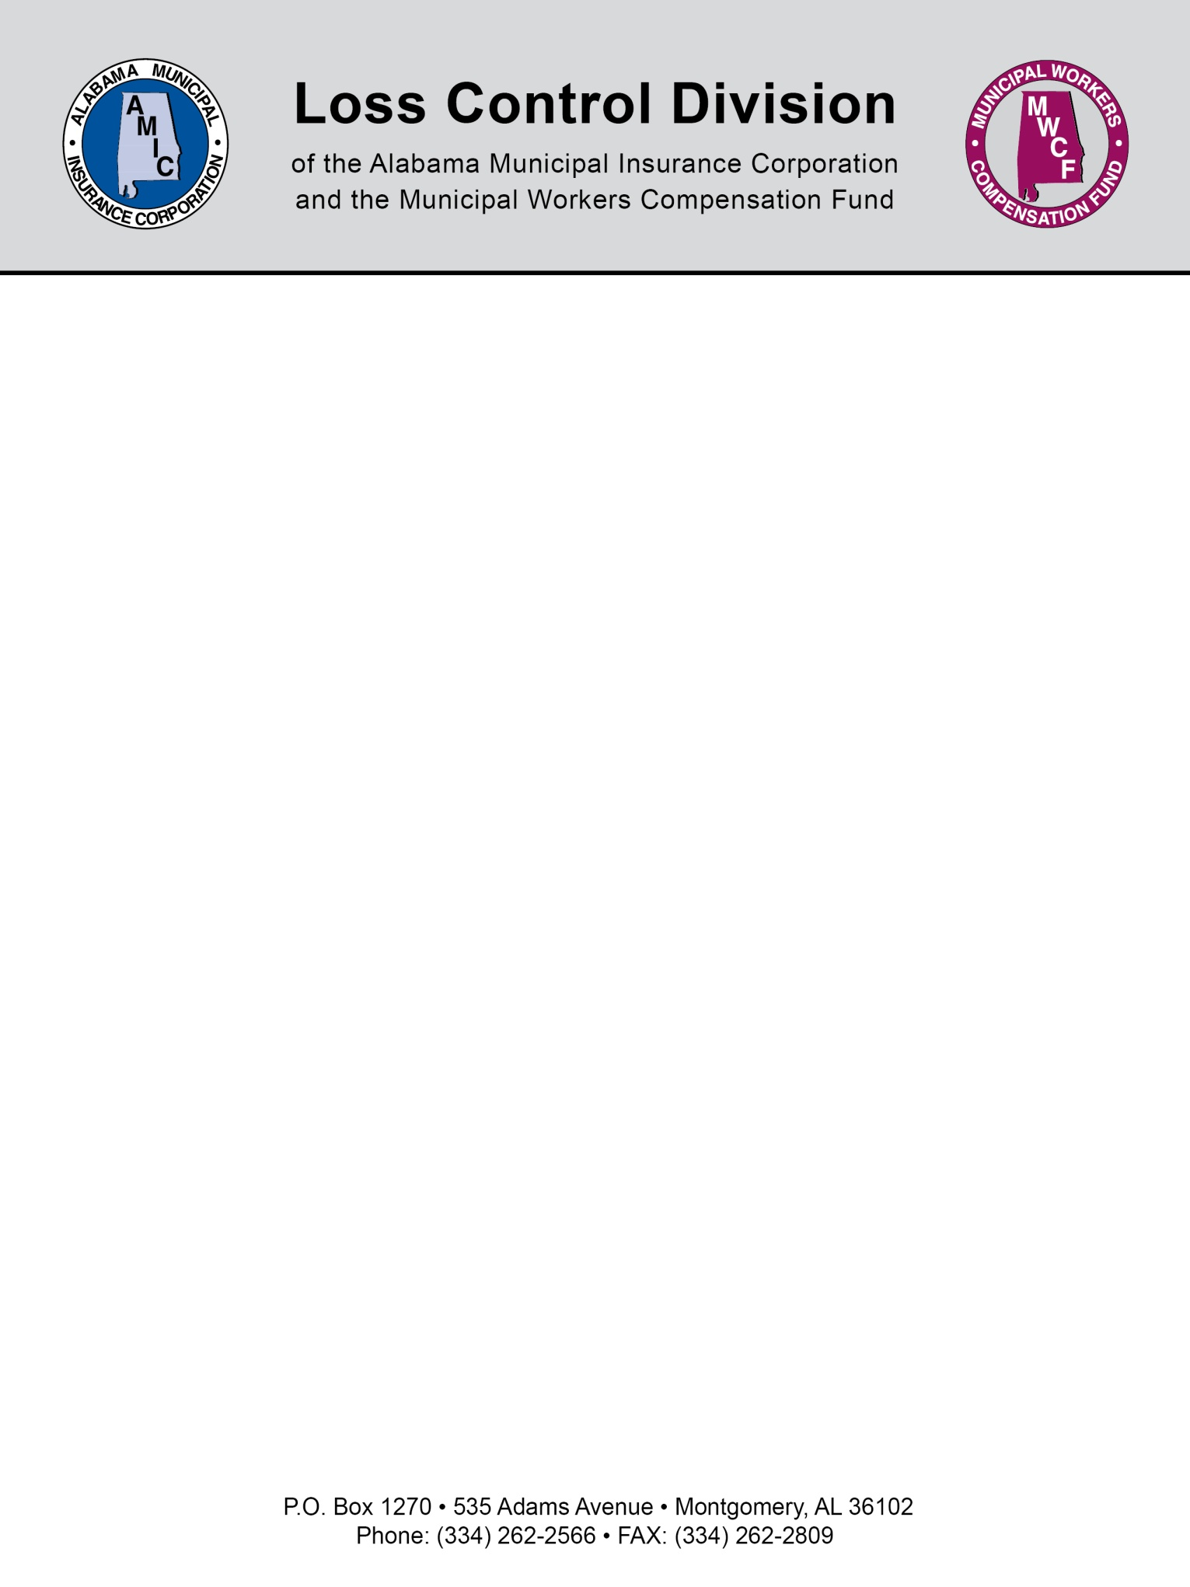

NFPA 1989 Standard on Breathing Air Quality for Fire and Emergency Services Respiratory Protection
The purpose of the NFPA 1989 is to establish criteria for a safe supply of breathing air for emergency services personnel who use atmosphere-supplying respirators that provide life support during rescue, confined space operations; hazardous materials operations; chemical, biological, radiological, and nuclear radiation (CBRN) terrorism incident operations; and special operations where respiratory hazards can or do exist.
In 2008, the National Fire Protection Association updated the standard on "Breathing Air Quality for Emergency Services Respiratory Protection." This standard is reviewed and revised every 5 years. We expect a new revision of this standard in 2013.
The NFPA 1989 standard is a copyrighted document so we cannot include the full text but we have highlighted some of the requirements. To find this NFPA document, visit www.nfpa.org, and search for NFPA 1989.

NFPA 1989 Specifications:

Analyte | NFPA 1989 2008 Edition Specification Limits
Oxygen | 19.5-23.5%
Carbon Monoxide | 5 ppm
Carbon Dioxide | 1000 ppm
Condensed Oil Mist and Particulate | 2.0 mg/m3
Water | 24 ppm
Tota Non-methane Volatile Organic Compounds (VOCs) | 25 ppm
Odor | No/slight odor acceptable
Nitrogen | 75-81%

Air Quality Periodic Requirements
Quarterly air analysis of samples shall be tested by an accredited laboratory and when contamination is suspected.

Air Samples
Air samples shall be taken downstream from purification components and prior to air storage cylinders. It is acceptable to use a remote fill hose or air sampling port, if samples are not able to be collected from inside of the containment fill station.

Special Testing and Procedures for Maintenance Conditions
Air samples shall be collected before and after changing the purification components or other times when breathing air contamination could occur, such as, after any alterations, maintenance, repair or relocation. Passing test results shall be received before returning the air compressor to service.

Special Testing and Procedures for Contaminated Air
When a sample fails to pass specification, air system must be removed from service, the cause determined, corrective action taken, retest performed, and a passing air test received before returning the system to service.

Compressed Breathing Air Systems
Compressors must be operated for at least 30 minutes each week with two condensate drain cycles. Air stored in steel cylinders must be replaced at least annually. The air system intake location must be acceptable and marked with a placard.

Special Circumstances (See Appendix for suggested procedure)
In the event of an emergency personnel's death, unconsciousness, or heart attack, the SCBA tank and chain of custody should be submitted to an accredited laboratory for analysis within 24 hours.

Records
The Emergency service organization shall maintain documentation from the accredited testing laboratory for 5 years. The accredited testing laboratory shall maintain documentation for 5 years.

Test Methods
TRI's AIHA accredited Air Testing Laboratory is in full compliance with the NFPA 1989 Breathing Air Quality for Emergency Services Respiratory Protection 2008 Edition.

NOTE: This document is not intended to be legal advice. It does not identify all the issues surrounding the particular topic. Public agencies are encouraged to review their procedures with an expert or an attorney who is knowledgeable about the topic. Reliance on this information is at the sole risk of the user.
Revised 9/2013

